EXC-01-02-02A | Form Number | Form:  Course Syllabus
2/3/24/2022/2963  05/12/2022 | Issue Number and Date | Form:  Course Syllabus
 | Number and Date of Revision or Modification | Form:  Course Syllabus
265/2024/24/3/2 | Deans Council Approval Decision Number | Form:  Course Syllabus
2024/1/23 | The Date of the Deans Council Approval Decision | Form:  Course Syllabus
06 | Number of Pages | Form:  Course Syllabus

1. | Course Title | Community Medicine
2. | Course Number | 0535205
3 | Credit Hours (Theory, Practical) | 4 credit hours (all theory)
3 | Contact Hours (Theory, Practical) | 64 hours
4. | Prerequisites/ Corequisites | None
5. | Program Title | Doctor of Medicine
6. | Program Code | ---
7. | School/ Center | The University of Jordan
8. | Department | Family and Community Medicine
9. | Course Level | 2nd medical year
10. | Year of Study and Semester (s) | Second year / First semester
11. | Program Degree
12. | Other Department(s) Involved in Teaching the Course | None
13. | Learning Language | English
14. | Learning Types | ☐Face to face learning ☒ Blended ☐Fully online
15. | Online Platforms(s) | ☒Moodle ☒ Microsoft Teams
16 | Issuing Date | October 2026
17. | Revision Date

Name: Dr. Ruba Habahbeh
Contact hours:
Office number: Phone number:
Email: r_alhabahbeh@ju.edu.jo

19. Other Instructors:
Name: Dr. Sireen Alkhaldi
Office number: 135/ Dept. Family & Community Medicine
Phone number: -----
Email: s.alkhaldi@ju.edu.jo
Contact hours:

Name: Rania Albsoul
Office number: 147- Family and Community Medicine Department
Phone number: ------------
Email: r.Absoul@ju.edu.jo
Contact hours:

Name: Dr. Munir Abu-Hilalah
Office number: ……..Dept. Family & Community Medicine
Phone number: -----
Email: m.abu-helalah@ju.edu.jo
Contact hours: Available by appointment
Office Hours:------------

Name: Dr. Mishkah Bani Mustafa
Office number: …………
Phone number: -------
Email: m.banimustafa@ju.edu.jo
Contact hours: ----------------

20. Course Description:
This course is designed to deliver knowledge of principles and practice of prevention in primary health care for medical students. It also provides students with core skills in epidemiology and biostatistics essential for medical research. This course highlights important community health domains such as mother and child health, environmental and occupational health, in addition to health services management.
B. The aim of this course is to introduce public health fundamentals such as epidemiology and biostatistics. Also, it aims to apply public health principles to health problems and develop strategies to address public health problems. It introduces students to primary healthcare, mother and child health, environmental health, and health administration.

21. Program Intended Learning Outcomes: (To be used in designing the matrix linking the intended learning outcomes of the course with the intended learning outcomes of the program)

*National Qualifications Framework Descriptors* |  |  |  | PLO’s
Knowledge (A) | Skills (B) | Competency (C)
☒ | ☐ | ☐ | 1.
☐ | ☐ | ☒ | 2.
☐ | ☒ | ☐ | 3.
☐ | ☒ | ☐ | 4.
☐ | ☐ | ☒ | 5.
 | ☒ | ☐ | 6.
☒ |  |  | 7.
 | ☒ |  | 8.
* Choose only one descriptor for each learning outcome of the program, whether knowledge, skill, or competency.

22. Course Intended Learning Outcomes: (Upon completion of the course, the student will be able to achieve the following intended learning outcomes)
Course ILOs # | The learning levels to be achieved |  |  |  |  |  | Competencies
Course ILOs # | Remember | Understand | Apply | Analyze | Evaluate | Create | Competencies
1 | ☒ | ☒ |  |  |  |  | Define key epidemiological concepts and describe the historical development of epidemiology, disease transmission and natural history of disease; explain association and causation and distinguish the major types of epidemiological studies, their applications, strengths and limitations. (Knowledge)
2 | ☒ | ☒ | ☒ | ☒ | ☒ |  | Calculate and interpret measures of disease frequency and association, including incidence and prevalence; describe disease surveillance and medical screening and calculate and interpret sensitivity, specificity, positive predictive value and negative predictive value. (skill)
3 | ☒ | ☒ | ☒ |  |  |  | Describe the epidemiology and prevention of communicable and non-communicable diseases, with emphasis on cancer, influenza and pneumococcal disease, and describe smoking epidemiology, health consequences, nicotine dependence and evidence-based tobacco cessation interventions (skill)
4 | ☒ | ☒ |  |  |  |  | Describe the principles, elements and requirements of primary health care and explain the role of health education; describe key maternal, child and adolescent health problems, including major causes of morbidity and mortality, maternal morbidities, and strategies for prevention (knowledge)
5 | ☒ | ☒ |  |  |  |  | Describe the burden, risk factors, health consequences and prevention strategies for injuries and violence against women and children.  (knowledge)
6 | ☒ | ☒ |  |  |  |  | Describe key concepts of environmental and occupational health, including air pollution and workplace hazards, and explain the roles of public health nutrition and demography in understanding and addressing community health problems (knowledge).
7 | ☒ | ☒ | ☒ | ☒ | ☒ |  | Apply basic statistical concepts, including variables and measurement scales, probability, descriptive statistics and hypothesis testing; select appropriate statistical techniques for health research and use SPSS to conduct and interpret basic analyses, including Chi-square, t-test, ANOVA, correlation and linear regression, and interpret statistical output in a public health context
8 | ☒ | ☒ |  |  |  |  | Identify the functions of healthcare managers, explain the role of motivation in healthcare, and describe the basic concepts of healthcare quality and patient safety.

23. The matrix linking the intended learning outcomes of the course -CLO’s with the intended learning outcomes of the program -PLOs:
PLO’s  *  CLO’s | 1 | 2 | 3 | 4 | 5 | 6 | 7 | 8 | 9 | 10 | Descriptors**
 |  |  |  |  |  |  |  |  |  |  | A | B | C
1
2
3
4 | ☒ | ☒ | ☒ | ☒ | ☒ | ☒ | ☒ | ☒ | ☒ | ☒ |  | ☒
5
6
7
8

*Linking each course learning outcome (CLO) to only one program outcome (PLO) as specified in the course matrix.
**Descriptors are determined according to the program learning outcome (PLO) that was chosen and according to what was specified in the program learning outcomes matrix in clause (21).

24. Topic Outline and Schedule:
Week | Lecture | Topic | ILO/s Linked to the Topic | Learning Types  (Face to Face/ Blended/ Fully Online) | Platform Used | Synchronous / Asynchronous Lecturing | Evaluation Methods | Learning Resources
1 | 1.1 | Introduction to Epidemiology | 1 | Face to face | - | Synchronous | Written exams | ppt
1 | 1.2 | Historical Evolution of Epidemiology | 1 | Face to face | - | Synchronous | Written exams | ppt
1 | 1.3 | Disease Transmission and Natural History of Disease | 1 | Face to face | - | Synchronous | Written exams | ppt
 | 1.4 | Incidence and prevalence | 2 | Blended | Moodle | Asynchronous | Written exam/  Online activities
2 | 2.1 | Preventive Medicine and cancer control | 3 | Face to face | - | Synchronous | Written exams | ppt
2 | 2.2 | Smoking and Smoking Cessation interventions | 3 | Face to face | - | Synchronous | Written exams | ppt
2 | 2.3 | Disease Surveillance and Medical Screening Part 1 | 2 | Face to face | - | Synchronous | Written exams | ppt
 | 2.4 | Infectious Diseases Epidemiology | 3 | Blended | Moodle | Asynchronous | Written exam/  Online activities
3 | 3.1 | Medical Screening part 2 | 2 | Face to face | - | Synchronous | Written exams | ppt
3 | 3.2 | Population pyramids and standardization | 6 | Face to face | - | Synchronous | Written exams | ppt
3 | 3.3 | Overview of Research design | 1 | Face to face | - | Synchronous | Written exams | ppt
 | 3.4 | Epidemiology and prevention | 3 | Blended | Moodle | Asynchronous | Written exam/  Online activities
4 | 4.1 | Introduction to primary health care | 4 | Face to face | - | Synchronous | Written exams | ppt
4 | 4.2 | Basic concepts on primary health care | 4 | Face to face | - | Synchronous | Written exams | ppt
4 | 4.3 | health education | 4  . | Face to face | - | Synchronous | Written exams | ppt
 | 4.4 | Astana declaration | 4 | Blended | Moodle | Asynchronous | Written exam/  Online activity
5 | 5.1 | Environmental health | 6 | Face to face |  | Synchronous | Written exam | ppt
5 | 5.2 | Occupational health | 6 | Face to face |  | Synchronous | Written exam | ppt
5 | 5.3 | Air pollution | 6 | Face to face |  | Synchronous | Written exam | ppt
 | 5.4 | Risk matrix | 6 | Blended | Moodle | Asynchronous | Written exam/ online activities
6 | 6.1 | The Public Health Importance of Maternal Health | 4 | Face to face |  | Synchronous | Written exam | ppt
6 | 6.2 | Maternal mortality and morbidity | 4 | Face to face |  | Synchronous | Written exam | ppt
6 | 6.3 | Common maternal morbidities in pregnancy | 4 | Face to face |  | Synchronous | Written exam | ppt
 | 6.4 | Inclusive and Respectful  Maternity Care | 4 | Blended | Moodle | Asynchronous | Written exam/ online activities
7 | 7.1 | Maternal health services (Preconception antenatal and postnatal care) | 4 | Face to face | - | Synchronous | Written exams | ppt
7 | 7.2 | Child Health1: global burden, Mortality, and Immunization | 4 | Face to face | - | Synchronous | Written exams | ppt
7 | 7.3 | Child health 2: Early Childhood Development, Nutrition | 4 | Face to face | - | Synchronous | Written exams | ppt
 | 7.4 | Kangaroo mother care (World Health Organization 2025) | 4 | Blended | Moodle | Asynchronous | Written exam/  Online activities
8 |  | Midterm exam | 1,2,3,4,6
9 | 9.1 | Demography (part 1) | 6 | Face to face | - | Synchronous | Written exams
9 | 9.2 | Demography (part 2) | 6 | Face to face | - | Synchronous | Written exams
9 | 9.3 | Demographic transition | 6 | Face to face | - | Synchronous | Written exams
 | 9.4 | Population pyramids | 6 | Blended | Moodle | Asynchronous | Written exam/  Online activities
10 | 10.1 | Child health 3 (growth monitoring, child disability) | 4 | Face to face | - | Synchronous | Written exams
10 | 10.2 | Adolescents | 4 | Face to face | - | Synchronous | Written exams | ppt
10 | 10.3 | Mental health | 4 | Face to face | - | Synchronous | Written exams | ppt
 | 10.4 | Screen time and development | 4 | Blended | Moodle | Asynchronous | Written exam/  Online activities
11 | 11.1 | Violence against women | 5 | Face to face | - | Synchronous | Written exams | ppt
11 | 11.2 | Violence against children | 5 | Face to face | - | Synchronous | Written exams | ppt
11 | 11.3 | injuries | 5 | Face to face | - | Synchronous | Written exams | ppt
 | 11.4 | Bullying | 5 | Blended | Moodle | Asynchronous | Written exam/  Online activities
12 | 12.1 | Measures of central tendency | 7 | Face to face | - | Synchronous | Written exams | ppt
12 | 12.2 | Measures of dispersion | 7 | Face to face | - | Synchronous | Written exams | ppt
12 | 12.3 | Descriptive visualization of data | 7 | Face to face | - | Synchronous | Written exams | ppt
 | 12.4 | Sampling method | 7 | Blended | Moodle | Asynchronous | Written exam/  Online activities
13 | 13.1 | Types of Variables and Levels of Measurement | 7 | Face to face | E-learning | Synchronous | Exam | Ppt
13 | 13.2 | Probability and the Normal Distribution | 7 | Face to face | E-learning | Synchronous | Exam | Ppt
13 | 13.3 | Introduction to Hypothesis Testing | 7 | Face to face | E-learning | Synchronous | Exam | ppt
 | 13.4 | Introduction to SPSS for statistical analysis | 7 | Blended | Moodle | Asynchronous | Written exam/  Online activities | ppt
14 | 14.1 | Introduction to health management | 8 | Face to face | e-learning | Synchronous |  | ppt
14 | 14.2 | Management and Motivation in Healthcare | 8 | Face to face | e-learning | Synchronous |  | ppt
14 | 14.3 | Quality and Safety Healthcare | 8 | Face to face | e-learning | Synchronous |  | ppt
 | 14.4 | Video about Swiss Cheese Model and its Link to Patient Safety | 8 | Blended | Moodle | Asynchronous
 | 15 | Final exam |  | 4-8 |  |  |  | Written exam

25. Evaluation Methods:
Opportunities to demonstrate achievement of the ILOs are provided through the following assessment methods and requirements:
Evaluation Activity | *Mark wt. | CLO’s
Evaluation Activity | *Mark wt. | 1 | 2 | 3 | 4 | 5 | 6 | 7 | 8
Midterm Exam | 40% | * | * | * | * |  | *
Online Activities | (A total of 30% of mid  and final exams mark  weight will be for activities) | * | * | * | * | * | * | * | * | * | *
Final Exam | 60% |  |  |  | * | * | * | * | * | * | *
Field visits | - | - | - | - | - | - | - | - | - | - | -
Practical and clinical | - | - | - | - | - | - | - | - | - | - | -
Performance  Completion file | - | - | - | - | - | - | - | - | - | - | -
Presentation/  exhibition | - | - | - | - | - | - | - | - | - | - | -
Any other approved works | - | - | - | - | - | - | - | - | - | - | -
Total 100% | 100%
* According to the instructions for granting a bachelor’s degree.
**According to the principles of organizing semester work, tests, examinations, and grades for the bachelor’s degree.

Mid-term exam specifications table*
CLO no. | CLO/  Weight | Total no. of questions | Total exam mark | No. of questions per CLO | No. of questions/ cognitive level
 |  |  |  |  | Remember  30% | Understand  20% | Apply  20% | analyse  10% | Evaluate  10% | Create  10%
 |  | 40 | 40 |  | 12 | 8 | 8 | 4 | 4 | 4

Final exam specifications table
CLO no. | CLO  Weight | Total no. of questions | Total exam mark | No. of questions per CLO | No. of questions/ cognitive level
 |  |  |  |  | Remember  30% | Understand  20% | Apply  20% | analyse  10% | Evaluate  10% | Create  10%
 |  | 60 | 60 |  | 20 | 12 | 10 | 6 | 6 | 6

26. Course Requirements:
- ✓ Class room Lectures
- ✓ Internet connection
- ✓ Online educational material using Moodle platform (Electronic Videos and Activities)

27. Course Policies:
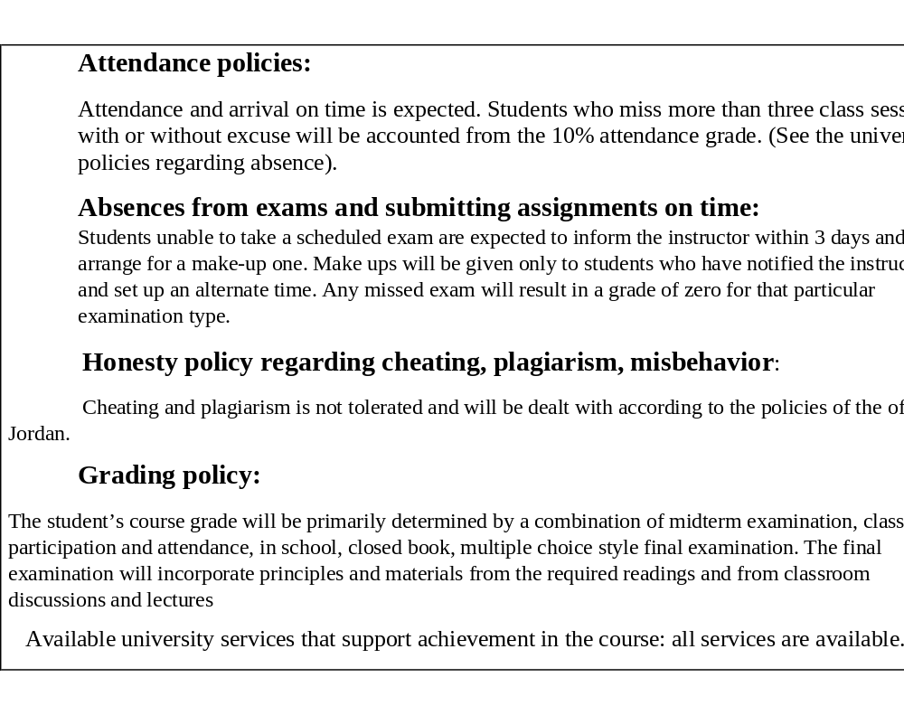

28. References:
A- Required book(s), assigned reading and audio-visuals:
• PowerPoint presentations will be posted on the E-learning.
• Selected supplemental websites and articles (blended) will be posted on the E-learning. You are responsible for all supplemental readings. Supplemental material will be discussed in class and included in tests.
B- Recommended books, materials, and media:
1. Epidemiology
Merrill, Ray (2012). Introduction to Epidemiology (6th Edition). Burlington, Massachusetts; United States: Jones & Bartlett.
2. Biostatistics: A Foundation for Analysis in the Health Sciences 10th Edition
by Wayne W. Daniel (Author), Chad L. Cross (Author) William Mendenhall, Introduction to Probability and Statistics, 15th edition, 2019
3. Community medicine: Population and Family Health Survey Jordan. 2023
Birkhead, G.S., Morrow, C.B., & Pirani, S. (2021). Essentials of public health (4th edition). Jones & Bartlett Learning
4. Environment: Frumken, H., Environmental Health (from global to local) 3rd edition, 2016
5. Leadership and Management
Neil Gopee and Jo Galloway (2013). Leadership and Management in Healthcare (2nd Edition). Washington DC; United States: SAGE Publications Ltd.
6. Skolnik, R. (2021). Global health 101 (4th ed.). Jones & Bartlett Learning.
7. Devakumar, D., Hall, J., Qureshi, Z., & Lawn, J. (Eds.). (2018). Oxford textbook of global health of women, newborns, children, and adolescents. Oxford University Press

29. Additional information:

Name of Course Coordinator: Dr. Ruba Habahbeh Signature: Date: 10/2026
Head of Curriculum Committee/Department: Dr. Sireen Alkhaldi Signature: --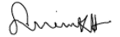
Head of Department: Dr. Sireen Alkhaldi Signature:
Head of Curriculum Committee/Faculty: --------------------------------- Signature: ---
Dean: ---------------------------------------------------------- Signature: ----------------------------

